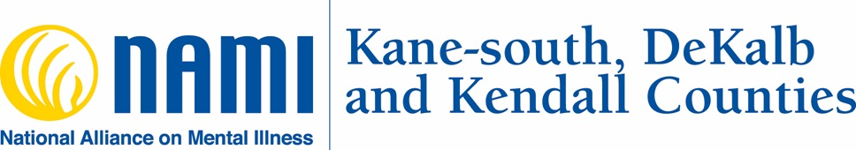
Video Conferencing and Telephonic Informed Consent for
NAMI KDK Support Groups

What is Telemental Health?
“Telemental Health” is the provision of mental health services with the provider and recipient of services being in separate locations, and the services being delivered over electronic media. NAMI KDK does not provide therapeutic mental health services, but rather provides services using trained facilitators and peer counselors with lived experience with a mental health diagnosis.
Services delivered via telemental health over electronic media rely on a number of electronic, often Internet-based, technology tools. These tools may include videoconferencing software, email, text messaging, virtual environments. Here at NAMI KDK, as we adjust to the daily changes and restrictions with regard to COVID-19 we plan to provide these services using the following tools:
Namikdk.org
Facebook Messenger
Email
Phone
Zoom.us
*You will need access to Internet services and a computer, iPad, or smartphone in order to engage in video conferencing telemental health work with your provider. You will need access to a cell phone with cellular data or a landline with active telephone service for phone conferencing.
Benefits and Risks of Telemental Health
Receiving services via telemental health allows you to:
- Receive services at times or in places where the service may not otherwise be available.
- Receive services in a fashion that may be more convenient and less prone to delays than in-person meetings.
- Receive services when you are unable to travel to the NAMI KDK Support Group locations.
- The unique characteristics of telemental health media may also help some people make improved progress on mental health goals that may not have been otherwise achievable without telemental health.
Receiving services via telemental health has the following risks:
- Telemental health services can be impacted by technical failures, may introduce risks to your privacy, and may reduce NAMI KDK’s ability to directly intervene in crises or emergencies. Here are a few examples:
- Internet connection and cloud services could cease working or become too unstable to use
- Cloud-based service personnel, IT assistants, and malicious actors (hackers) may have the ability to access your private information that is transmitted or stored in the process of telemental health-based service delivery
- Computer or smartphone hardware can have sudden failures and run out of power, or local power services can go out.
- Technical failure interruptions may disrupt services at important moments, and NAMI KDK may be unable to reach you quickly using another communication method or using the most effective tools. NAMI KDK will also be able to help you in-person should a technical failure occur.
- There may be additional benefits and risks to telemental health services that arise from the lack of in-person contact of presence, the distance between you and NAMI KDK at the time of service, and the technological tools used to deliver services. NAMI KDK will assess these potential benefits and risks, sometimes in collaboration with you, as your relationship progresses. We anticipate offering in person meetings again in the near future, with the potential to continue to offer on-line support options.
Assessing Telemental Health’s Fit for You
Although it is well validated by research, service delivery via telemental health is not a good fit for every person. NAMI KDK will continuously assess if working via telemental health is appropriate for your case. If it is not appropriate, NAMI KDK will attempt to help you find in-person providers with whom to continue services, however this may be very difficult because of the in-person restrictions at this time due to COVID-19.
Please talk to NAMI KDK if you find the telemental health media so difficult to use that distracts from the services being provided, if the medium causes trouble focusing on your services, or if there are any other reasons why the telemental health medium seems to be causing problems in receiving services. Raising your questions or concerns will not result in termination of services. Brining your concerns to NAMI KDK is often a part of the process.
You also have a right to stop receiving services by telemental health at any time. At this time NAMI KDK is not able to provide in person sessions with clients because of restrictions due to COVID-19. If you decide not to participate in sessions either by phone and/or video, then NAMI KDK will seek to refer you to an outside agency/provider who is providing in-person services.
Your Telemental Health Environment
You will be responsible for creating a safe and confidential space during sessions. You should use a space that is free of other people and avoid public Wi-Fi. It should also be difficult or impossible for people outside the space to see or hear your interactions with NAMI KDK during the session. If you are unsure of how to do this, please ask NAMI KDK for assistance.
Our Safety and Emergency Plan
As a recipient of telemental health-based services, you will need to participate in ensuring your safety during mental health crises, medical emergencies, and sessions that you have with NAMI KDK. NAMI KDK will require you to designate an emergency contact. You will need to provide permission for NAMI KDK to communicate with this person about your care during emergencies. NAMI KDK will also develop with you a plan for what to do during mental health crises and emergencies, and a plan for how to keep your space safe during sessions. It is important that you engage with NAMI KDK in the creation of these plans and that you follow them when you need to.
Your Security and Privacy
Except where otherwise noted, NAMI KDK has taken great effort to employ software and hardware tools that adhere to security best practices and applicable legal standards for the purposes of protecting your privacy and ensuring that records of your health care services are not lost or damaged. As with all things in telemental health, however, you also have a role to play in maintaining your security. Please use reasonable security protocols to protect the privacy of your own health care information. For example: when communicating with NAMI KDKD, use devices and service accounts that are protected by unique passwords that only you know.
Recordings
Please do NOT record ANY video or audio sessions with NAMI KDK. Making recordings can quickly and easily compromise your privacy, and the privacy of others, and you may be prohibited from future support group participation through on-line support. NAMI KDK will NOT record video or audio sessions.

